AI RESUME SCREENING SYSTEM
Smart Candidate Matching Platform — A Full-Stack Web Application with CI/CD & Cloud Deployment
Prepared in the partial fulfillment of the Summer Internship Program on AWS
AT


Under the guidance of
Mr. J. Lovababu, APSSDC
Submitted by
- Karanam Sharmila, 5201421049,GVPCDPGC Visakhapatnam,(Batch-2)
- Goli Nithin, 23475A0520,nec,(Batch-2)
- Jampana Gangadhar Srikanth, Y22CM064,R.V.R & J.C COLLEGE OF ENGINEERING,(Batch-2)
- Y Konda Harshini, 23781A3547, Sri Venkateshwara College of Engineering and Technology Chittoor,(Batch-2)

ACKNOWLEDGEMENT
We would like to express our heartfelt gratitude to all those who have contributed to the successful completion of our summer internship project at the Andhra Pradesh State Skill Development Corporation (APSSDC). This opportunity has been an enriching and transformative experience, and we are truly thankful for the support, guidance, and encouragement we have received throughout the internship.
We extend our sincere gratitude to Mr. J Lovababu, our mentor and trainer at APSSDC, for his valuable guidance, continuous encouragement, and unwavering support throughout the development of our project, “AI Resume Screening System.” His expertise, constructive feedback, and motivation were instrumental in the successful completion of this project.
We would also like to express our sincere thanks to the entire team at the Andhra Pradesh State Skill Development Corporation (APSSDC) for providing a collaborative, innovative, and supportive learning environment. The knowledge, resources, and practical exposure gained during this internship have greatly enhanced our technical skills and understanding of full-stack development and DevOps practices.
Finally, we are grateful to our families and friends for their constant encouragement, patience, and support throughout this learning journey. We are honored to have been a part of this internship program and look forward to applying the skills and knowledge we have gained in our future academic and professional endeavors.
Thank you.
Sincerely,
Karanam Sharmila, 5201421049, ksharmikrishna@gmail.com
Goli Nithin, 23475A0520, nithin934767@gmail.com
Jampana Gangadhar Srikanth, Y22CM064, gangadharjampana757@gmail.com
Y Konda Harshini, 23781A3547, harshinikonda066@gmail.com
ABSTRACT
This project presents the implementation of the AI Resume Screening System, a full-stack web application that automates and simplifies the resume screening process in recruitment using modern DevOps practices. The primary objective is to streamline candidate evaluation by integrating an AI-driven matching engine with a fully automated CI/CD and cloud deployment pipeline, reducing manual effort, minimizing evaluation inconsistency, and ensuring faster, more reliable hiring decisions.
The workflow begins when a recruiter uploads a candidate's resume (PDF) and a job description through a React.js frontend. The FastAPI backend receives the request, parses the resume to extract candidate details, and uses an AI Matching Engine to compare candidate skills against the job requirements, calculating a Resume Match (ATS) Score. Missing skills are identified and improvement recommendations are generated, and the complete record is persisted in a SQLite database via SQLAlchemy ORM.
The solution utilizes GitHub for source code management, Jenkins for CI/CD pipeline automation, Docker and Docker Compose for containerization of the frontend and backend services, Terraform for infrastructure provisioning, and AWS EC2 for cloud hosting. This automated pipeline builds, tests, and deploys the containerized application to the cloud without manual intervention.
This automated system improves recruitment efficiency by enabling consistent, objective candidate evaluation, dashboard analytics, leaderboard ranking, resume search and score-based filtering, all exposed through RESTful APIs documented with Swagger UI. Containerization with Docker eliminates environment-specific issues, making deployment more reliable, portable, and scalable.
By implementing DevOps principles and automation alongside AI-driven resume matching, this project demonstrates how React, FastAPI, Docker, Jenkins, and AWS can be effectively integrated to build a robust, cloud-deployed recruitment platform. It provides a strong foundation for future enhancements such as LLM-based semantic analysis, PostgreSQL migration, role-based authentication, and multi-language resume support.

TABLE OF CONTENTS
S.No | Content | Pg.No
1. | INTRODUCTION | 5–6
2. | OBJECTIVES | 6–7
3. | METHODOLOGY | 7–9
4. | TECHNOLOGY STACK | 9–13
5. | SYSTEM ARCHITECTURE | 13–22
6. | IMPLEMENTATION | 22–27
7. | PIPELINE WORKFLOW | 27–30
8. | RESULTS | 30–32

1. INTRODUCTION
The rapid growth of digital recruitment platforms has dramatically increased the volume of job applications received by organizations. In traditional recruitment, resume screening is often performed manually, which can be time-consuming, inconsistent, and prone to human error. Recruiters reviewing hundreds or thousands of resumes for a single opening frequently reject qualified candidates simply because keyword-based Applicant Tracking Systems (ATS) fail to understand context or terminology differences. These challenges delay hiring decisions, increase recruiter workload, and reduce overall productivity.
Modern AI approaches — using natural language processing (NLP), semantic analysis, and machine learning — provide far more accurate resume-to-job matching than legacy keyword search, while containerization and CI/CD tools such as Docker and Jenkins simplify the deployment and scaling of such systems. The adoption of DevOps practices enables organizations to deliver and update recruitment software quickly, consistently, and with greater confidence.
This project, “AI Resume Screening System,” demonstrates the practical implementation of an automated, cloud-deployed candidate-matching platform built with industry-standard tools. The project integrates React.js, FastAPI, SQLite, Docker, Jenkins, Terraform, and AWS EC2 to create a complete automation workflow that minimizes manual intervention. When a recruiter uploads a resume and job description, the system automatically parses the resume, matches candidate skills against the job requirements, calculates a Resume Match (ATS) Score, and stores the results for search, filtering, and leaderboard ranking.
Docker plays a crucial role in this project by packaging the frontend and backend, along with all required dependencies, into lightweight containers. This ensures that the application behaves consistently across development, testing, and production environments, eliminating common issues such as dependency conflicts and environment mismatches. Jenkins acts as the automation server that orchestrates the entire workflow, enabling seamless integration between source code management, application building, containerization, and deployment to AWS EC2.
The implementation of this system significantly reduces resume screening time, improves evaluation consistency, and enhances recruiter productivity by automating repetitive tasks. This project provides practical exposure to modern DevOps practices and demonstrates how automation, containerization, and AI-driven matching can transform the recruitment lifecycle. It serves as a strong foundation for understanding enterprise-level deployment strategies and can be further enhanced with LLM-based semantic analysis, PostgreSQL migration, role-based authentication, and multi-language resume support.

2. OBJECTIVES
The primary objective of this project is to design and implement an automated resume screening platform, built with React.js and FastAPI and delivered through a Jenkins CI/CD pipeline using Docker and AWS EC2. The project aims to demonstrate how DevOps practices and AI-assisted matching can improve recruitment by automating resume parsing, skill comparison, scoring, and deployment, resulting in faster, more reliable, and consistent candidate evaluation.
The specific objectives of this project are as follows:
1. To understand and implement the fundamental concepts of DevOps, Continuous Integration (CI), and Continuous Deployment (CD) in the context of a recruitment platform.
2. To develop a React.js frontend enabling recruiters to upload resumes, enter job descriptions, and view results.
3. To build a FastAPI backend exposing RESTful APIs for resume screening, dashboard analytics, search, and filtering.
4. To extract candidate information — name, email, phone, skills, education, and experience — from uploaded PDF resumes.
5. To compare extracted candidate skills with job description requirements and calculate a Resume Match (ATS) Score.
6. To automatically identify matched and missing skills and generate improvement recommendations.
7. To store all screening results in a centralized SQLite database using SQLAlchemy ORM.
8. To containerize the frontend and backend using Docker and Docker Compose, ensuring consistent execution across environments.
9. To configure Jenkins as an automation server so that new commits automatically trigger the build and deployment pipeline.
10. To provision and deploy the application on AWS EC2 using Terraform, exposing the required ports through a security group.
11. To gain practical experience with industry-standard DevOps tools, including GitHub, Jenkins, Docker, Terraform, and AWS EC2, and to demonstrate a real-world CI/CD workflow that can be extended with LLM-based semantic analysis, PostgreSQL migration, and role-based authentication.
By achieving these objectives, the project demonstrates the practical application of DevOps and AI-assisted automation principles in streamlining recruitment, improving development productivity, and enabling faster, scalable, and reliable candidate screening.

3. METHODOLOGY
The methodology followed in this project is based on the DevOps Continuous Integration and Continuous Deployment (CI/CD) approach, combined with an AI-assisted resume-matching workflow. The project automates the software development and deployment lifecycle using GitHub, Jenkins, Docker, Terraform, and AWS EC2. Each stage of the pipeline is designed to reduce manual effort, improve deployment reliability, and ensure that application updates are delivered efficiently.
3.1 Project Planning
The first step involved identifying the project requirements and selecting the appropriate tools for both the application and its automation. React.js was chosen for the frontend, FastAPI for the backend and resume-processing logic, SQLite with SQLAlchemy for data storage, Docker and Docker Compose for containerization, Jenkins as the automation server, Terraform for infrastructure provisioning, and AWS EC2 for cloud hosting.
3.2 Source Code Management
The frontend, backend, and Dockerfiles were stored in a GitHub repository. Developers make changes to the application and push the updated code to GitHub, which serves as the single source of truth for the project and enables version control and collaboration.
3.3 Resume Parsing & Skill Matching Configuration
The backend was configured with PyMuPDF (fitz) to extract text and candidate details from uploaded PDF resumes. An AI Matching Engine was implemented to compare the extracted skills against the job description, compute the Resume Match (ATS) Score, and identify matched and missing skills.
3.4 Continuous Integration — Jenkins
A Jenkins pipeline was created to automate the Continuous Integration process. Whenever new code is pushed to the GitHub repository, Jenkins automatically detects the changes and triggers the pipeline. The pipeline performs the following tasks:
- Retrieves the latest source code from GitHub.
- Builds the React frontend and FastAPI backend.
- Verifies that the build process completes successfully.
- Prepares the application for containerized deployment.
This automated integration process ensures that code changes are continuously validated and reduces the risk of integration issues.
3.5 Docker Image Creation
After the application is successfully built, Jenkins uses separate Dockerfiles to create Docker images for the frontend and backend, each containing the application and its required dependencies. Docker packages both services into lightweight containers, ensuring that they behave consistently across different environments.
3.6 Automated Deployment
Once the Docker images are successfully created, Jenkins automatically deploys the application using Docker Compose, which orchestrates the frontend and backend containers together. Terraform provisions the underlying AWS EC2 infrastructure and security group. Existing containers can be stopped and replaced with the updated version to ensure seamless deployment.
3.7 Testing and Verification
After deployment, the application is tested by accessing it through the configured EC2 public IP and port. The successful execution of the application confirms that the CI/CD pipeline has completed all stages correctly. Jenkins console logs and Docker container status are also verified to ensure successful deployment.
3.8 Result Evaluation
The performance of the implemented CI/CD pipeline is evaluated based on successful automation of the build and deployment process. The project demonstrates reduced deployment time, fewer manual errors, improved consistency, and faster software delivery compared to traditional manual deployment methods.
Methodology Workflow
The complete methodology of the project follows the sequence below:
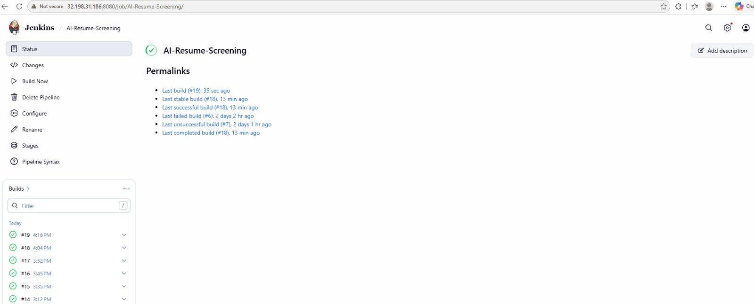
Figure 1. Jenkins Pipeline — AI-Resume-Screening job with successful builds
This methodology successfully demonstrates the implementation of a modern DevOps workflow using Jenkins, Docker, and AWS. By automating software integration and deployment alongside AI-driven resume matching, the project improves efficiency, enhances reliability, and provides a scalable solution for continuous, cloud-hosted recruitment screening.

4. TECHNOLOGY STACK
The successful implementation of the AI Resume Screening System relies on a set of modern full-stack and DevOps tools and technologies. Each technology plays a specific role in automating resume analysis, application delivery, containerization, and deployment. The technology stack used in this project is described below.
4.1 React.js
React.js is a JavaScript library used to build the interactive frontend of the application. It provides the recruiter-facing interface for uploading resumes, entering job descriptions, and viewing the dashboard, leaderboard, and search/filter results.
Features:
- Single-page application interface
- Component-based UI development
- Communicates with the backend via REST API calls (Axios)
- Dashboard, leaderboard and results views
4.2 FastAPI (Python)
FastAPI is a modern Python web framework used to build the backend RESTful APIs. It handles resume uploads, orchestrates resume parsing and AI matching, and serves dashboard, leaderboard, search, and filter data to the frontend.
Features:
- High-performance asynchronous REST APIs
- Automatic Swagger UI documentation
- Resume screening and scoring endpoints
- Integration with the database via SQLAlchemy ORM
4.3 SQLite + SQLAlchemy
SQLite is a lightweight, file-based database used to store all candidate and screening data, accessed through the SQLAlchemy ORM. It centrally stores candidate information, job descriptions, matched/missing skills, scores, recommendations, and timestamps.
Features:
- Centralized candidate data storage
- ORM-based data access and management
- Supports search, filter, and leaderboard queries
- Lightweight, file-based deployment
4.4 PyMuPDF (fitz)
PyMuPDF is a Python library used to extract text and structured information from uploaded PDF resumes. It enables the Resume Parser to retrieve candidate name, email, phone, skills, education, and experience from raw PDF content.
Features:
- PDF text extraction
- Supports structured candidate-field parsing
- Fast and lightweight processing
- Works directly on uploaded resume files
4.5 Docker + Docker Compose
Docker is a containerization platform that packages the frontend and backend, along with their dependencies, into lightweight containers. Docker Compose orchestrates the multi-container application, ensuring the frontend and backend run together consistently.
Features:
- Frontend and backend containerization
- Portable, multi-container deployment
- Consistent runtime environment
- Lightweight compared to virtual machines
4.6 Jenkins
Jenkins is an open-source automation server used to implement Continuous Integration and Continuous Deployment (CI/CD). It automates the build, containerization, and deployment process, eliminating manual intervention whenever new code is pushed to GitHub.
Features:
- Continuous Integration and Continuous Deployment
- Automated build and deployment execution
- Pipeline creation and build history
- Plugin support for Git and Docker
4.7 AWS EC2 & Terraform
AWS EC2 provides the cloud compute instance that hosts the deployed application, while Terraform provisions and manages this infrastructure — including the EC2 instance and its security group — as code.
Features:
- Cloud hosting and deployment environment
- Infrastructure-as-code provisioning
- Security group controlling inbound ports
- Scalable, repeatable infrastructure setup
4.8 Git + GitHub
Git is used for local version control of the application source code, while GitHub hosts the central repository. Jenkins monitors this repository and automatically triggers the CI/CD pipeline whenever new commits are pushed.
Features:
- Source code version control
- Branching and commit history
- Central repository for collaboration
- Automatic pipeline triggering via Jenkins
4.9 Swagger UI & VS Code
Swagger UI is automatically generated by FastAPI to document and test the REST APIs, while Visual Studio Code (VS Code) served as the primary development environment for building and debugging the application.
Features:
- Auto-generated, interactive API documentation
- In-browser API testing
- Efficient code editing and debugging
- Extension support for Python, React and Docker
Technology Stack Summary
S.No. | Technology | Purpose
1. | React.js | Frontend user interface
2. | FastAPI (Python) | Backend REST APIs and resume processing
3. | SQLite + SQLAlchemy | Database storage and ORM management
4. | PyMuPDF (fitz) | PDF text extraction from uploaded resumes
5. | Docker + Compose | Containerization and multi-container management
6. | Jenkins | CI/CD pipeline automation
7. | Terraform | Infrastructure provisioning on AWS
8. | AWS EC2 | Cloud hosting and deployment environment
9. | Git + GitHub | Version control and source code hosting
10. | Swagger UI / VS Code | API documentation, testing and development environment
The combination of these technologies enables the successful implementation of an automated, AI-assisted resume screening pipeline. Together, they streamline the recruitment lifecycle by automating parsing, matching, containerization, and deployment, resulting in faster, more reliable, and consistent candidate evaluation.

5. SYSTEM ARCHITECTURE
The AI Resume Screening System is designed as an automated, layered client-server architecture that streamlines the resume screening and deployment process. The architecture integrates a React.js frontend, a FastAPI backend, an AI-driven processing layer, a SQLite database, and a Jenkins/Docker/AWS DevOps pipeline to enable end-to-end automation — from resume upload to cloud deployment.
The system follows a structured architecture consisting of a frontend layer, backend/API layer, processing layer, database layer, and a CI/CD deployment layer. Recruiters upload resumes and job descriptions through the frontend; the backend parses the resume, matches skills, and calculates the ATS score; the database stores every record; and the entire application is containerized and deployed to AWS EC2 through Jenkins.
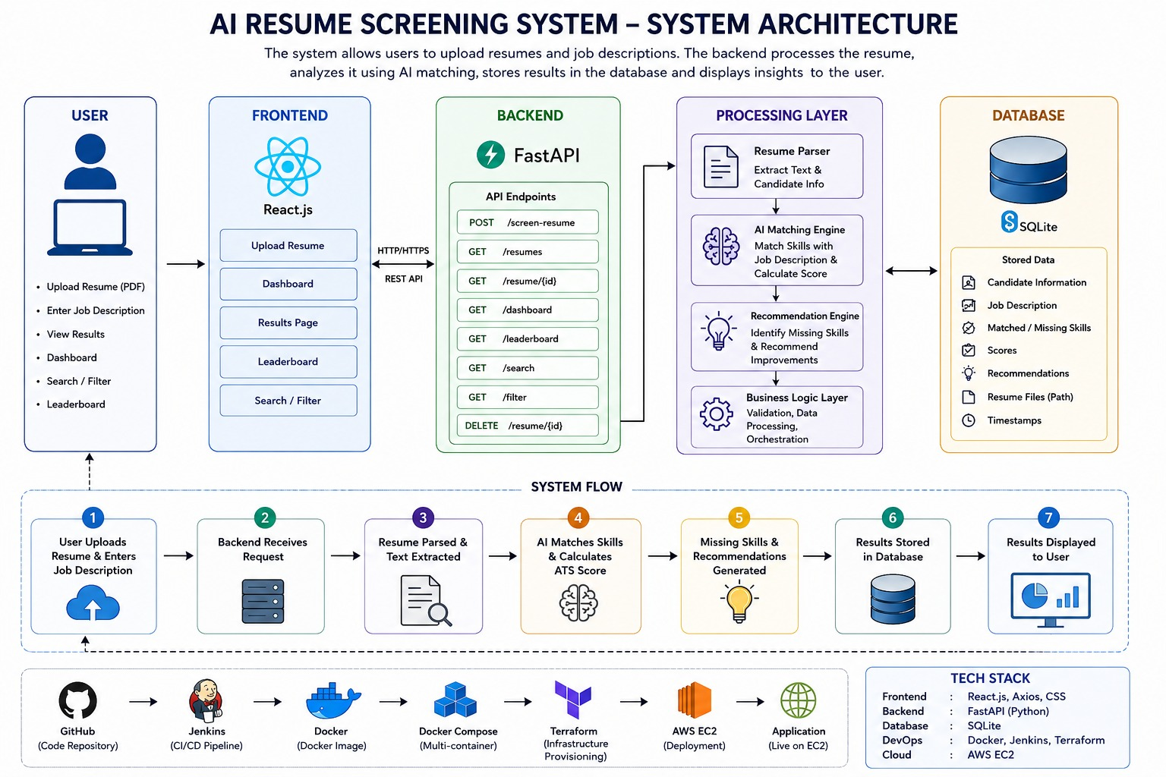
Figure 2. AI Resume Screening System — Complete System Architecture
This automated architecture provides a consistent deployment environment, improves software quality, enhances development productivity, and serves as a scalable foundation for modern DevOps practices.
5.1 Frontend Layer — React.js
The frontend is a single-page React.js application that provides the recruiter-facing interface. It communicates with the backend exclusively through REST API calls over HTTP/HTTPS, and includes screens for uploading resumes, viewing the dashboard, browsing the leaderboard, and searching/filtering candidates.
Key Features:
- Upload Resume — resume + job description submission form
- Dashboard — total resumes, highest/average score, selected candidates
- Results Page — per-candidate match score, matched/missing skills, recommendations
- Leaderboard — ranked candidate comparison
- Search / Filter — search by name, email or job; filter by score range
5.2 Backend Layer — FastAPI (API Endpoints)
The backend exposes a RESTful API built with FastAPI that receives requests from the frontend and orchestrates the processing layer and database.
Method | Endpoint | Purpose
POST | /screen-resume | Upload a resume + job description for screening
GET | /resumes | Retrieve all screened resumes
GET | /resume/{id} | Retrieve a single candidate's details
GET | /dashboard | Retrieve dashboard summary statistics
GET | /leaderboard | Retrieve ranked leaderboard data
GET | /search | Search resumes by name, email or job
GET | /filter | Filter resumes by score range
DELETE | /resume/{id} | Delete a candidate's resume record

Figure 3. Jenkins Pipeline — AI-Resume-Screening job with successful builds
5.3 Processing Layer
Module | Function
Resume Parser | Extracts text and candidate information (name, email, phone, skills, education, experience) from the uploaded PDF
AI Matching Engine | Matches extracted candidate skills against job description requirements and calculates the Resume Match (ATS) Score
Recommendation Engine | Identifies missing skills and generates improvement recommendations for the candidate
Business Logic Layer | Handles validation, data processing and orchestration between the parser, matching engine and database
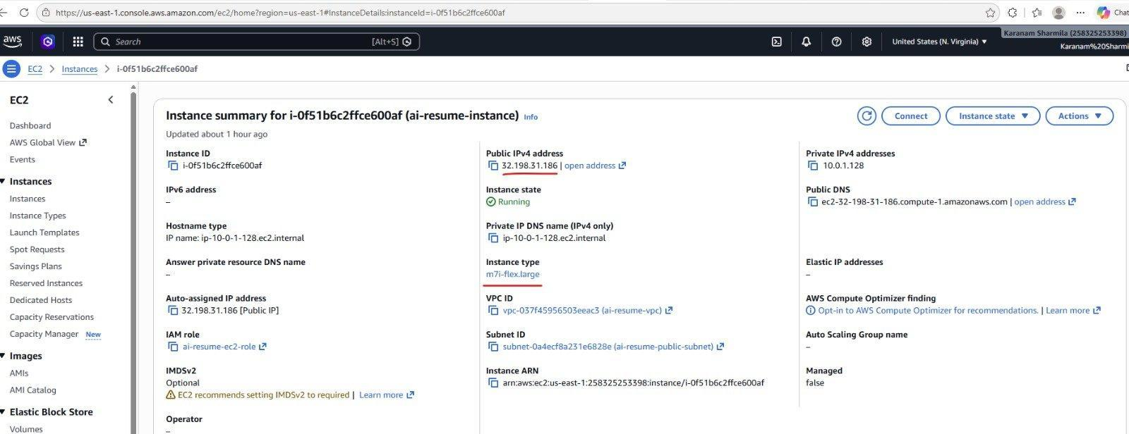
Figure 4. AWS EC2 Instance — ai-resume-instance running in us-east-1
5.4 Database Layer — SQLite
All processed data is stored centrally in a SQLite database, accessed through the SQLAlchemy ORM. The following data is persisted for every screened candidate:
- Candidate Information (name, email, phone, education, experience)
- Job Description
- Matched / Missing Skills
- Scores (Resume Match / ATS Score)
- AI Recommendations
- Resume File Path
- Timestamps
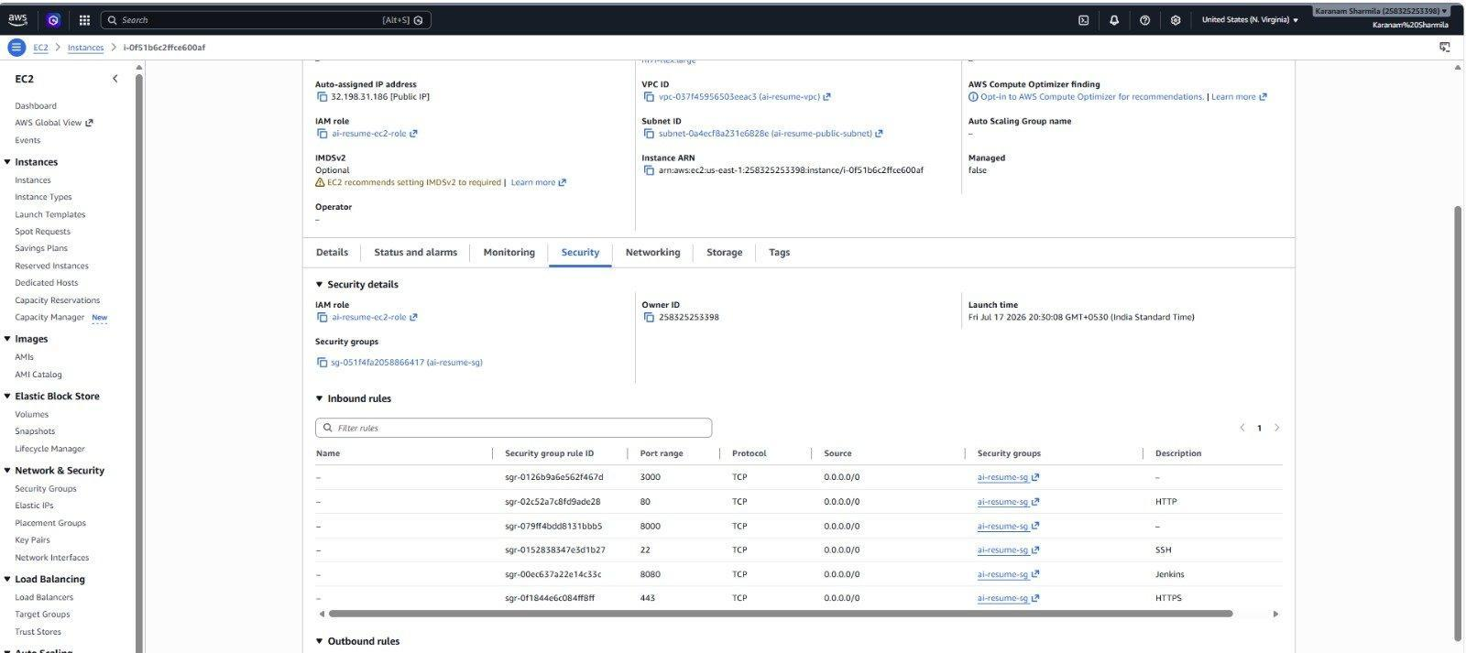
Figure 5. AWS Security Group inbound rules for ai-resume-instance
5.5 CI/CD & Deployment Layer
The application is built, containerized and deployed through an automated DevOps pipeline:
- GitHub — source code repository
- Jenkins — CI/CD pipeline that automates build and deployment
- Docker — builds the frontend and backend images
- Docker Compose — orchestrates the multi-container application
- Terraform — provisions the AWS infrastructure
- AWS EC2 — hosts and runs the deployed application
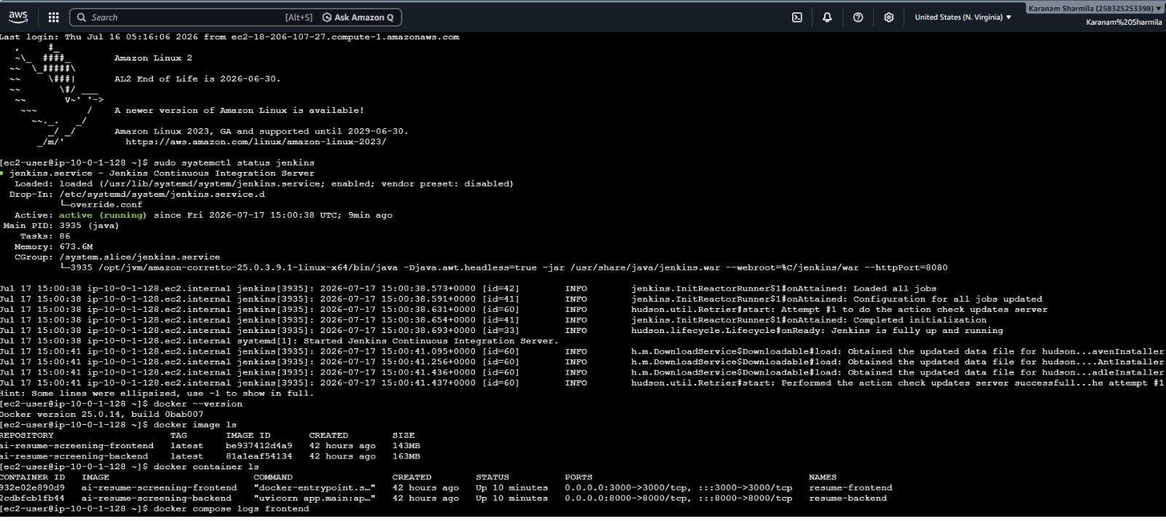
Figure 6. EC2 terminal — Jenkins status, Docker images & running containers
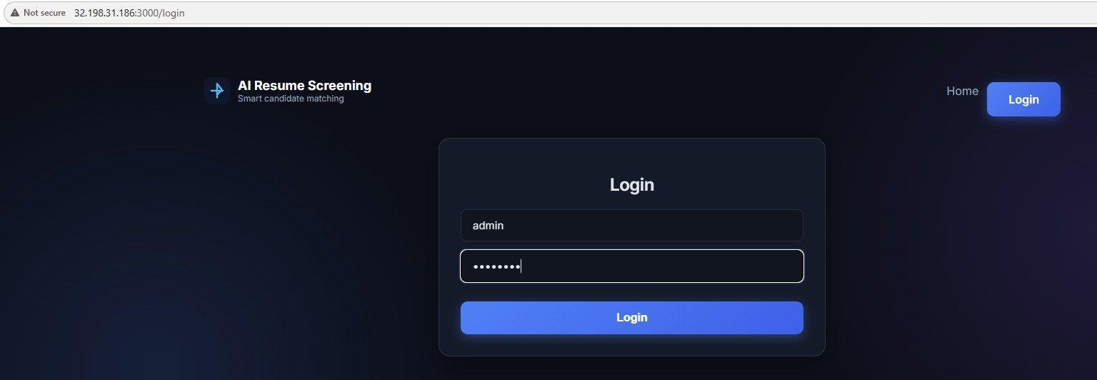
Figure 7. Live application — AI Resume Screening login page

6. IMPLEMENTATION
The implementation of the AI Resume Screening System focuses on automating resume analysis and the software build/deployment process using full-stack and DevOps tools. The project integrates React.js, FastAPI, Docker, Jenkins, Terraform, and AWS EC2 to create a seamless Continuous Integration and Continuous Deployment (CI/CD) workflow. The implementation is divided into several phases, each performing a specific task in the automation process.
6.1 Project Setup
The implementation began with the creation of an Ubuntu-based Amazon EC2 instance. The required software packages, including Docker, Docker Compose, Git, and Jenkins, were installed and configured. After installation, the Jenkins and Docker services were started, and the Jenkins user was added to the Docker group to enable Docker command execution from Jenkins.
Commands Used:
sudo apt update
sudo apt install docker.io docker-compose -y
sudo apt install git -y
sudo systemctl start docker
sudo systemctl enable docker
sudo systemctl start jenkins
sudo systemctl enable jenkins
sudo usermod -aG docker jenkins
sudo systemctl restart jenkins
6.2 GitHub Repository Configuration
The React frontend, FastAPI backend, and their Dockerfiles were uploaded to a GitHub repository. GitHub acts as the centralized version control platform, enabling the team to track changes and collaborate effectively. Jenkins was configured to access this repository and automatically trigger the CI/CD pipeline whenever new code was pushed.
Git Commands Used:
git init
git add .
git commit -m "Initial Commit"
git branch -M main
git remote add origin https://github.com/username/ai-resume-screening.git
git push -u origin main
6.3 Jenkins Pipeline Configuration
A Jenkins Pipeline job was created to automate the build and deployment process. The GitHub repository URL was configured in the Source Code Management section, and the pipeline was set to trigger automatically on new commits. Build stages execute the required commands to build, containerize, and deploy the application.
Build Commands:
docker build -t ai-resume-screening-frontend ./frontend
docker build -t ai-resume-screening-backend ./backend
docker compose down
docker compose up -d --build
These commands build the frontend and backend Docker images, stop any existing containers, and deploy the updated application automatically via Docker Compose.
6.4 Docker Image Creation
After the application was successfully built, Jenkins executed the frontend and backend Dockerfiles to create Docker images. Docker packages each service together with its required dependencies, ensuring consistent execution across different environments.
Command Used to Verify Docker Images:
docker images
6.5 Infrastructure Provisioning — Terraform
Terraform was used to provision the AWS EC2 instance and its security group as code, exposing only the ports required by the application (3000, 8000, 8080, 80, 443, and 22).
Commands Used:
terraform init
terraform plan
terraform apply -auto-approve
6.6 Automated Application Deployment
Once the Docker images were created, Jenkins deployed the application by running Docker Compose on the AWS EC2 instance. Before launching the updated containers, any previously running containers were stopped and removed to avoid conflicts.
Deployment Commands:
docker compose down
docker compose up -d --build
docker ps
6.7 Application Verification
After deployment, the application was verified by accessing it through a web browser using the AWS EC2 public IP address and the mapped port number.
Application URL:
http://32.198.31.186:3000
Additional commands were executed to verify the deployment status:
docker ps
docker logs resume-backend
systemctl status jenkins
systemctl status docker
The successful display of the application login page confirmed that the CI/CD pipeline had completed all stages successfully.

7. PIPELINE WORKFLOW
The CI/CD pipeline is the core component of this project, automating the resume-screening application's build and deployment lifecycle. The pipeline begins when a developer pushes the latest source code to the GitHub repository. Jenkins continuously monitors the repository and automatically triggers the pipeline whenever changes are detected.
Once the pipeline starts, Jenkins checks out the latest source code from GitHub and builds the React frontend and FastAPI backend. After a successful build, Jenkins builds Docker images for both services and uses Docker Compose to stop any existing containers and deploy the updated containers. The application is then hosted on AWS EC2 and becomes accessible to recruiters through a web browser.
This automated workflow eliminates manual deployment tasks, reduces configuration errors, ensures consistent deployments, and enables faster software delivery.
7.1 Pipeline Stages
Stage 1: Source Code Development
Developers write or modify the frontend and backend source code and commit the changes using Git.
git add .
git commit -m "Updated Application"
git push origin main
Stage 2: Source Code Management
The updated source code is pushed to the GitHub repository, which stores the latest version of the application and serves as the source repository for Jenkins.
Stage 3: Jenkins Pipeline Trigger
Jenkins continuously monitors the GitHub repository. When new code is detected, Jenkins automatically triggers the CI/CD pipeline.
Stage 4: Build Process
Jenkins retrieves the latest source code and builds the React frontend and FastAPI backend.
Stage 5: Docker Image Creation
After the build completes successfully, Jenkins builds Docker images for the frontend and backend.
docker build -t ai-resume-screening-frontend ./frontend
docker build -t ai-resume-screening-backend ./backend
Stage 6: Container Deployment
The existing containers are stopped and removed before deploying the updated application via Docker Compose.
docker compose down
docker compose up -d --build
Stage 7: Application Verification
After deployment, the running containers are verified.
docker ps
The application is then accessed through a web browser:
http://32.198.31.186:3000
7.2 Complete Pipeline Workflow
The complete workflow of the project is summarized below:
1. User — uploads resume and enters job description via the React UI
2. Backend (FastAPI) — receives the request
3. Resume Parser — parses the resume and extracts text
4. AI Matching Engine — matches skills and calculates the ATS score
5. Recommendation Engine — identifies missing skills and generates recommendations
6. Database — results are stored in the SQLite database
7. Dashboard — results are displayed to the user
Advantages of the Pipeline
- Automates the entire resume screening, build and deployment process.
- Reduces manual intervention and deployment errors.
- Ensures consistent application deployment using Docker containers.
- Enables rapid and reliable software delivery.
- Supports Continuous Integration and Continuous Deployment (CI/CD).
- Improves software quality and development productivity.
- Provides a scalable foundation for future LLM-based matching and cloud enhancements.
This pipeline workflow demonstrates the practical implementation of DevOps principles by integrating GitHub, Jenkins, Docker, Terraform, and AWS EC2 into a fully automated software delivery process for an AI-assisted recruitment platform. The automated pipeline ensures faster releases, improved reliability, and consistent deployments across different environments.

8. RESULTS
The implementation of the AI Resume Screening System was successfully completed, demonstrating an automated resume screening, build, and deployment process using full-stack development and DevOps practices. The integration of React.js, FastAPI, Docker, Jenkins, Terraform, and AWS EC2 enabled the application to be built, containerized, and deployed automatically with minimal manual intervention.
When a recruiter uploaded a resume and job description, the backend successfully parsed the resume, matched candidate skills against the job requirements, calculated the Resume Match (ATS) Score, identified missing skills, and generated recommendations. When developers pushed source code changes to GitHub, Jenkins successfully detected the changes and triggered the CI/CD pipeline, which built the application, created Docker images, and deployed the updated containers without manual intervention.
The Docker containers hosted the frontend and backend on AWS EC2, making the application accessible through a web browser using the configured public IP address and port numbers. Verification of the deployment confirmed that the application was running correctly and all pipeline stages executed successfully.
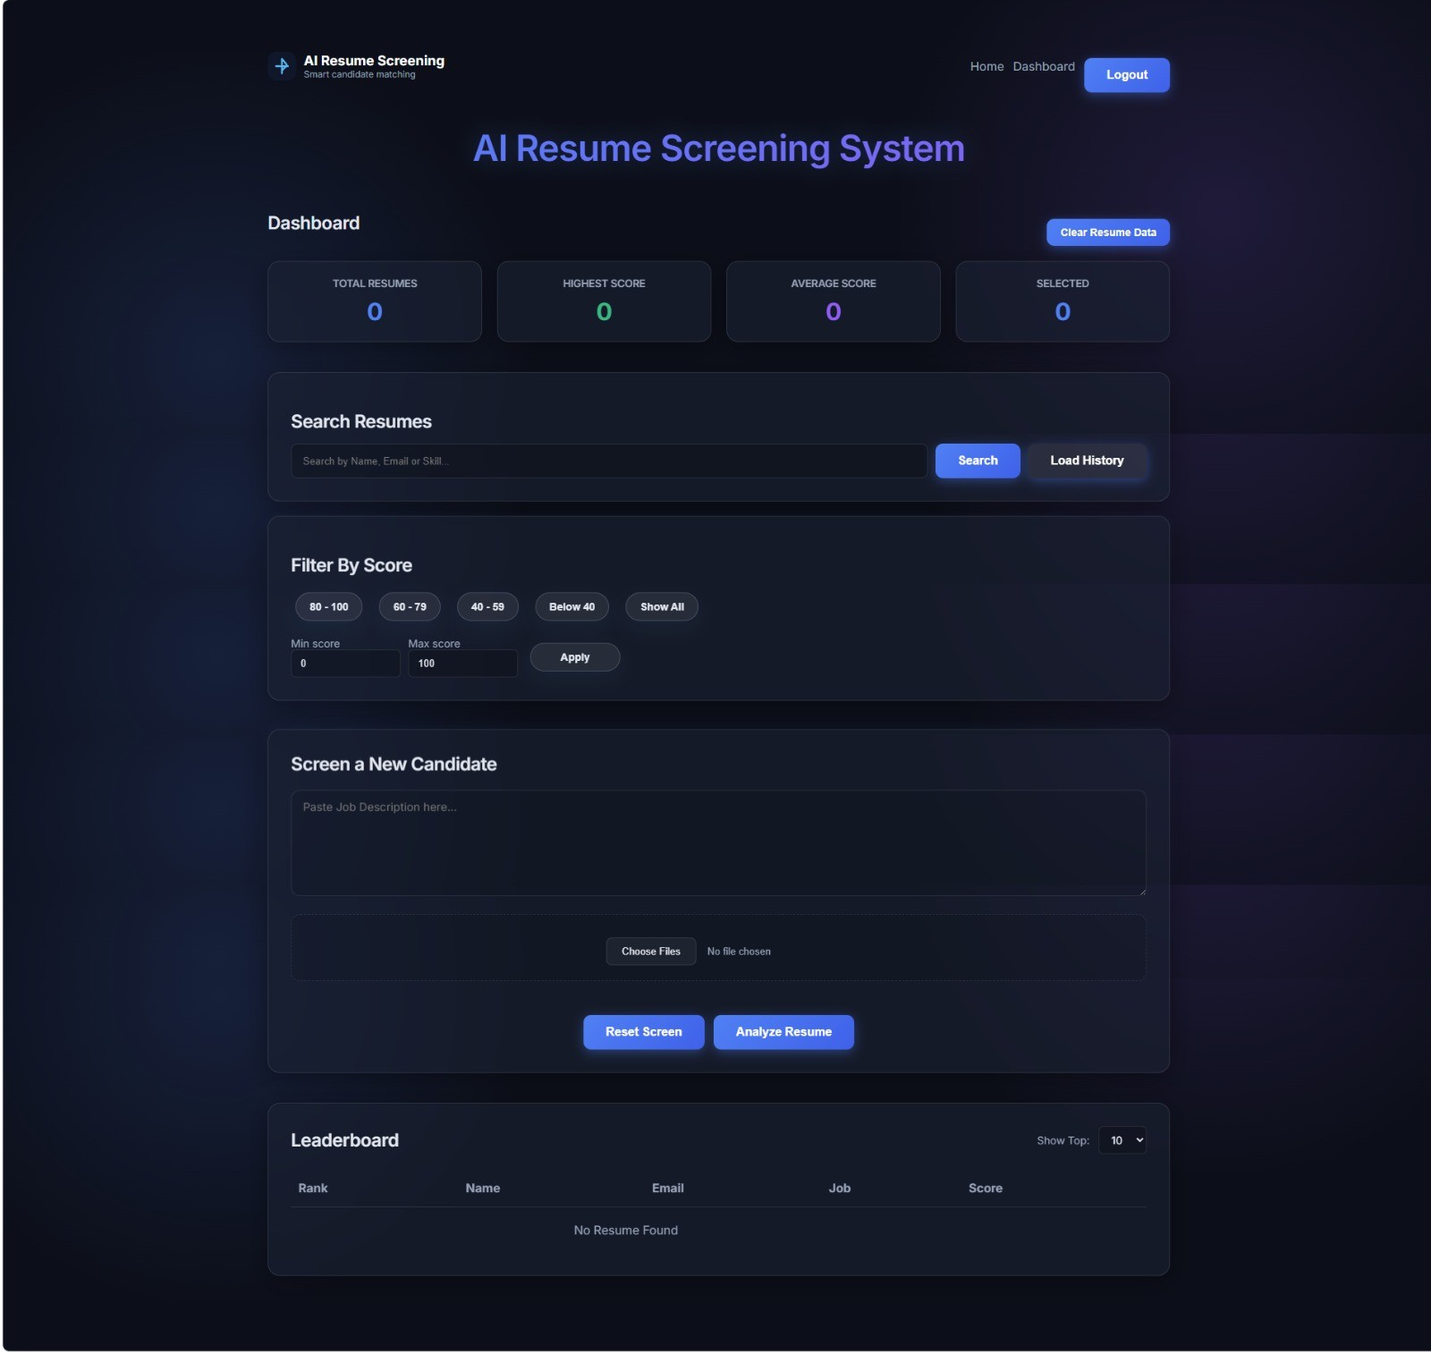
Figure 8. Dashboard before any resumes are screened
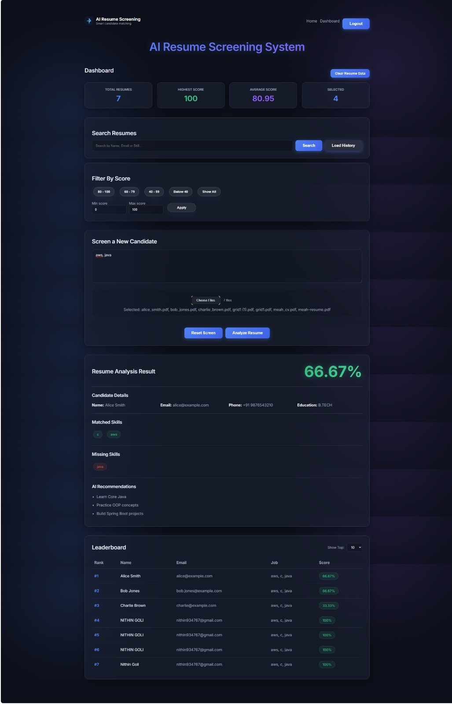
Figure 9. Dashboard after screening — scores, matched/missing skills, AI recommendations and leaderboard
The project significantly reduced the time required for resume screening and deployment compared to a traditional manual approach. Automation eliminated repetitive tasks, minimized deployment errors, and ensured a consistent deployment environment across different executions. Docker containerization also resolved dependency and environment-related issues by packaging each service and its required components into portable containers.
Overall, the project successfully demonstrated the practical implementation of Continuous Integration (CI) and Continuous Deployment (CD) using Jenkins, Docker, and AWS, combined with an AI-assisted resume-matching engine. The automated pipeline improved recruitment delivery speed, enhanced deployment reliability, and simplified application management.
8.1 Achieved Results
- Successfully configured Jenkins for Continuous Integration and Continuous Deployment.
- Integrated GitHub with Jenkins to automatically trigger builds on source code changes.
- Successfully built the React.js frontend and FastAPI backend.
- Created Docker images automatically for both frontend and backend services.
- Deployed the application using Docker Compose on AWS EC2.
- Implemented an AI Matching Engine that calculates a Resume Match (ATS) Score and identifies missing skills.
- Verified successful deployment through a web browser, including dashboard, leaderboard and search/filter features.
- Reduced manual deployment effort through complete automation.
- Improved deployment consistency, reliability, and candidate evaluation objectivity.
- Demonstrated real-world implementation of DevOps and AI-assisted recruitment principles.
8.2 Project Outcome
The project achieved all the planned objectives by successfully implementing an automated, AI-assisted resume screening platform with a fully automated CI/CD pipeline. The integration of React.js, FastAPI, SQLite, Docker, Jenkins, Terraform, and AWS EC2 enabled efficient software development, continuous integration, and automated deployment. The pipeline ensured faster releases, minimized human errors, and provided a reliable and scalable recruitment platform. This project serves as a strong foundation for implementing advanced enhancements such as LLM-based semantic resume analysis, PostgreSQL migration, role-based authentication, email notifications, cloud storage integration (S3), and multi-language resume support in future work.

